OWNER'S MANUAL

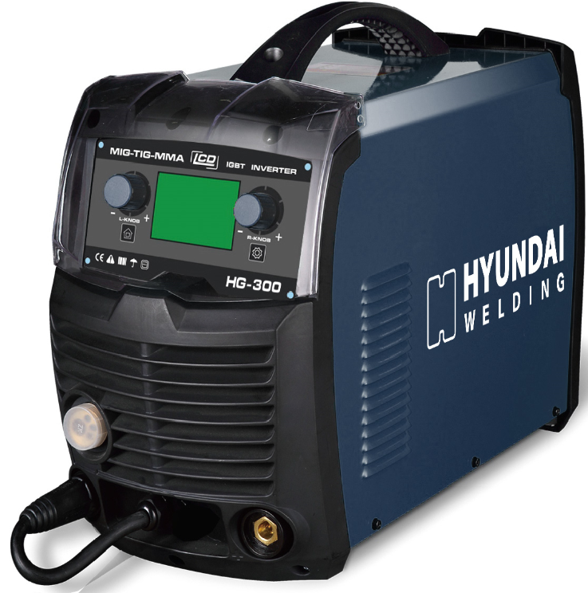

HG300

CONTENTS
- 1.Safety……………………..………………..…………………………….…..……....……………………………………………………. | 2
- 2.General Description……...………......……...…………………….………...……….....……………………………………….. | 3
-3.Main Parameter…….……...…...........…….....………………………………….…..……….…………………………………… | 5
- 4.Structure of welder…….……...…...........………………………..…………….…..……….…………………………………… | 7
- 5.Installation ……………………………………………………………………………………………………………………………….. | 8
- 6.Welding settings quick reference chart………………………………………………………………………………………. | 16
- 7.Range of welding current and voltage in CO2 welding...……….…………………………………………………… | 21
- 8.Welding parameters table.......…....................……………………….………..…………………………………………… | 21
- 9.Caution……….....................…………………………………………...………………. .....…...................................... | 24
- 10. Maintenance….………………………………………….……………….….……....….…………………………………………… | 25
- 11. Daily checking……………………………………….….……....….………………………………………….…………………….. | 26
- 12. Connection diagram of the machine………………………………….….……....….………………………………….. | 28
- 13. Explosion drawing…………………………..………………………………….….……....….………………………………….. | 39

이 용접기는 IEC974 표준을 준수하여 제작합니다.

따라서 구매 후 6개월 동안 이 용접기에 대해 보증합니다.

이 용접기를 설치하고 사용하기 전에 취급설명서를 충분히 읽고 이해하십시오.

이 취급설명서의 내용은 사전 통지없이 개정 될 수 있습니다.

이 취급설명서는 2019년 10월에 발행되었습니다.

1. 안전에 관한 주의사항
사용자가 장비를 올바르게 사용하지 않으면 사용자 및 주변 사람들에게 매우 위험합니다. 따라서 용접 / 절단을 하실 경우 모든 안전 관련 규정을 엄격히 준수해야 합니다. 설치 및 작동 전에 이 취급설명서를 충분히 읽고 이해하십시오.
● 용접 중에는 기능 모드 전환이 기계에 손상을 줄 가능성이 있습니다.
· 용접하기 전에 기기와 전극 홀더 케이블을 분리하십시오.
· 기기의 누전을 방지하기 위해 안전 스위치가 필요합니다.
· 용접 공구의 품질 상태가 유지되어야 합니다.
· 취급자의 경우 전기 관련된 자격이 있어야 합니다.

● 감전 : 치명적일 수 있습니다.
· 표준 규정에 따라 접지 케이블을 연결하십시오.
· 맨손으로 용접 회로, 전극 및 전선의 전기 부품과 접촉하지 않도록 하십시오.
· 작업자는 용접 작업을 수행하는 동안 건조된 용접 장갑을 착용해야 합니다.
· 작업자는 반드시 절연에 주의하십시오.

● 용접 또는 절단시 발생하는 연기 및 가스 : 건강에 해로우니 주의하십시오.
· 용접 또는 절단시 발생하는 연기 및 가스를 흡입하지 마십시오.
· 작업 장소를 환기 시키십시오.

● 아크 : 사람의 눈과 피부에 해롭습니다.
· 용접을 하는 동안 용접 헬멧, 방사선 방지 유리 및 작업복을 착용하십시오.
· 작업장 내부 또는 근처의 사람들을 보호하기 위한 조치를 취해야 합니다.

● 화재 위험
· 용접 스패터는 화재의 원인이 되므로 작업장에서 가연성 물질을 제거하십시오.
· 소화기를 근처에 두고, 훈련 된 사람이 사용할 수 있도록 준비 시키십시오.

● 소음 : 사람들의 청각에 해로울 수 있습니다.
· 용접 / 절단시 소음 발생, 소음이 크면 승인된 귀마개를 착용하십시오

● 기계 고장 :
·이 취급설명서를 참조하십시오.
· 자세한 문의사항은 지역 영업담당자 또는 공급업체에 문의하십시오.

2. 용접기 일반 설명

이 용접기는 당사에서 설계한 IGBT 인버터 기술을 기반으로 제작한 MIG 용접기 전원 공급 장치로 구성됩니다.
고출력 부품인 IGBT를 사용하면 인버터는 입력 50Hz / 60Hz AC 전압에서 정류된 DC 전압을 고주파수 20KHz
AC 전압으로 변환합니다. 결과적으로 전압이 변환되고 정류가 됩니다.
이 기기의 기능은 다음과 같습니다.
● IGBT 인버터 기술, 전류 제어, 고품질, 안정적인 성능
● 폐회로 제어, 고정 전압 출력, 최대 ± 15%의 균형 전압
● 전자 리액터 제어, 안정적인 용접, 저 스패터, 깊은 용융 풀, 우수한 용접 비드 형성
● 용접 전압을 설정할 수 있으며 전압계는 용접하지 않을 때, 미리 설정된 전압 값을 표시합니다.
● 용접 전류와 용접 전압을 동시에 확인할 수 있습니다.
● 와이어 공급 부는 용접기에 포함되어 있습니다.
● 크기가 작고 가벼워 실용적입니다.

구성품
아래 목록에 있는 모든 구성품이 양호한 상태인지 확인하십시오.
포함 된 품목 :

번호. | 부품 | 수량. | 사진
1 | MIG Welder | 1set
2 | Operator’s Manual | 1pc
3 | Electrode Holder | 1pc | 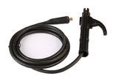
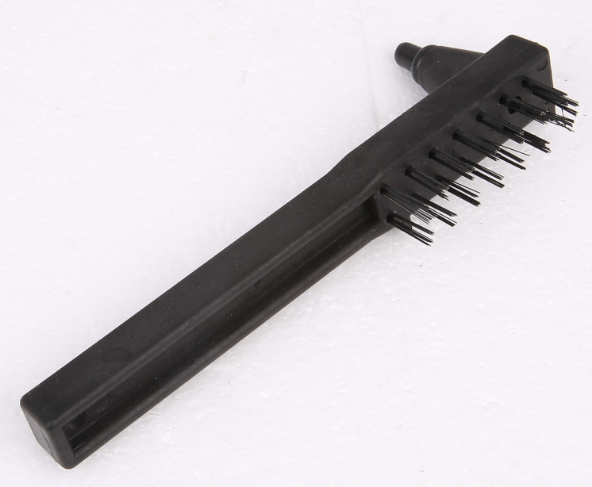  4 | Earth Clamp | 1pc | 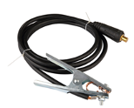
5 | 3m MIG torch | 1pc | 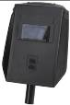  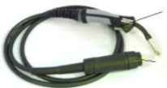

운영 환경

용접기의 냉각을 위해서는 적절한 환기가 필요합니다. 기기를 시원한 공기가 쉽게 흐를 수 있는 안정된 장소에 설치하십시오. 용접기에는 전기 부품과 제어회로기판이 있어 과도한 먼지로 인해 손상 될 수 있으므로 깨끗한 작동 환경이 필수적입니다.

일반 연결도

LIFT TIG는 접촉식 아크 TIG라고도합니다.
필요한 품목 : LIFT TIG 기능이 있는 인버터 용접기, 접지 케이블 및 LIFT TIG용 토치

LIFT TIG의 사용 방법은 다음과 같습니다.
접지 케이블은 음극 출력 단자에 연결하고 가스호스는 알곤 가스의 가스 유량계와 연결합니다. 가스호스에는
너트 커버가 있으며 가스 레귤레이터와 연결할 수 있습니다. 가스 유량계와 너트의 나사 규격은 동일해야 합니다.
다음 아르곤 가스의 밸브를 열고 가스 유량계의 밸브를 열면 TIG토치의 가스 조절 밸브를 조정하여 가스 흐름을
조절 할 수 있습니다. 텅스텐 전극봉이 모재에 닿도록 하고 TIG 토치를 조금 위로 들어 올린 다음 용접 작업을
진행하십시오.
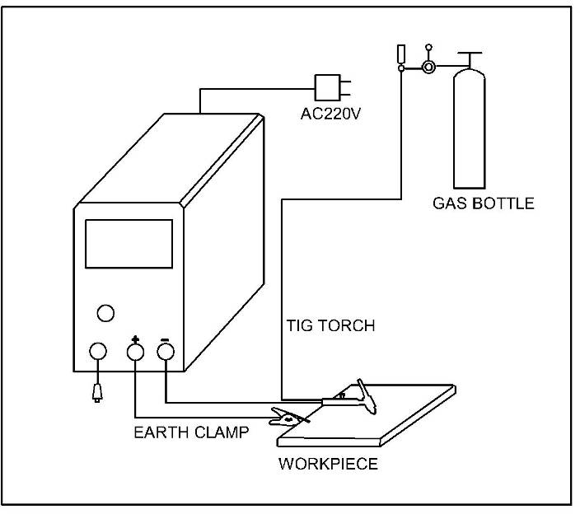

MAIN PARAMETER
3.2 15KG Wire Spool Models

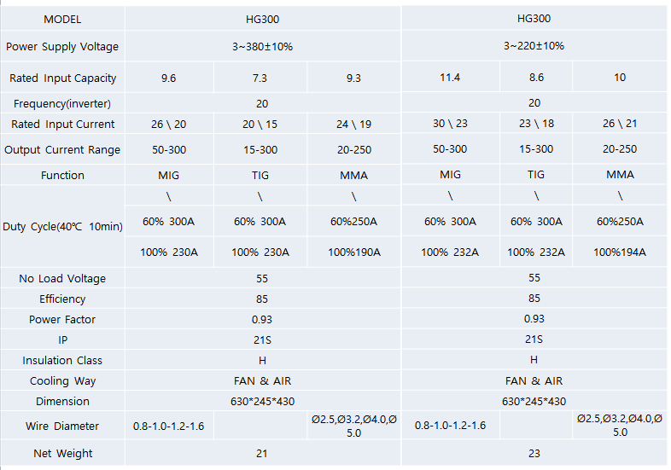

참고
- 용접 사용률은 10분 사이클에서 발생할 수 있는 실제 연속 용접 시간의 백분율입니다.
예를 들어, 200A에서 15% 용접기는 10분 주기로 1.5분 동안 200A에서 연속적으로 용접 후 장치를 8.5분 동안 쉬어야 합니다.
- 본 용접기는 입력전압이 230V(±10%)으로 110V입력에 사용하실 수 없습니다. 사용에 주의해주시기 바랍니다.
- 용접기의 사용률은 작업 환경에 따라서 영향을 받을 수 있습니다.
- 온도가 40℃를 초과하는 지역에서는 사용률이 명시된 것보다 낮을 수 있습니다..
- 사용률에 대한 모든 테스트는 해당 사용률 및 전류보다 가혹한 조건에서 실시하였습니다.
따라서 실제 작업 조건에서 사용률은 위에서 언급한 것보다 훨씬 높습니다.

용접기 구조
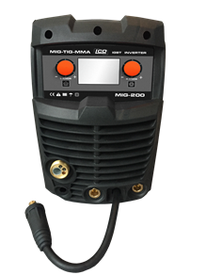
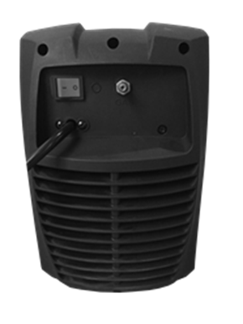
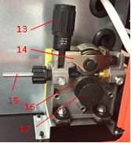
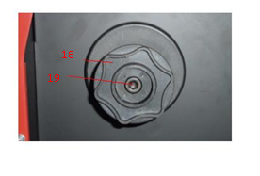
- 왼쪽노브/ 모드설정 및 볼트값조정
- 왼쪽버튼/ home 버튼
- 오른쪽노브/용접조건값설정
- 오른쪽버튼/용접조건값설정/와이어속도/와이어경/IND/2T4T/핫스타트/아크포스
5. 미그토치 유로타입 커넥터
6. + 출력단자
7. – 출력단자
8. 극성 변환케이블
9. 파워스위치
10. 가스 주입구
11. 전원 케이블
13. 가압레버
14. 가압부, 가압롤러
15. 와이어 가이드
16. 와이어피더 롤러
17. 와이어피더 롤러 잠금장치
18. 와이어스풀 브라켓
19. 와이어스풀 조임 너트
1
2
3
4

5
6
7
8
10
11
9
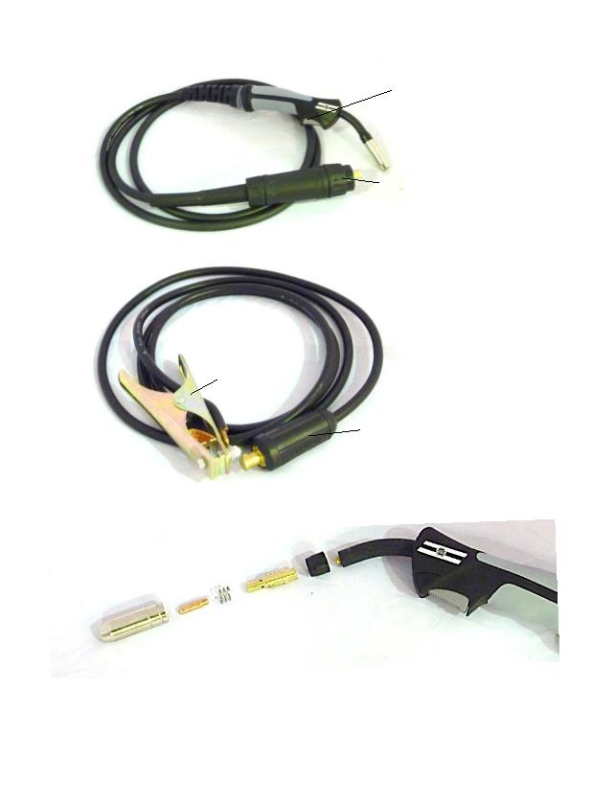
20
21
22
23
24
25
26
27

20. Torch trigger switch
21. Torch “Euro” connector
22. Workpiece earth clamp
23. Earth lead quick connector
24. Conical gas nozzle/shroud
25. Welding tip
26. Shroud spring
27. Tip adapter

5.INSTALLATION
5.1. MIG Welding Set Up & Operation
5.1.1 Fitting the spool
5.1.1.1 open the cover door for the wire feed compartment. Remove the wire spool retainer(18) by threading off anti clockwise.
5.1.1.2 fit the 200mm diameter wire spool to the spool holder, ensuring the end of the wires exits towards the wire feeder from the bottom of the spool. Refit the wire spool retainer(18) and tighten finger tight.
5.1.1.3 set the spool brake tension by rotating the adjustment screw(19) using an Allen wrench. Clockwise to increase brake tension, anti-clockwise to decrease brake tension. The spool brake tension should be set so that the spool can rotate freely, but does not continue to rotate once the wire feed stops. This may need to be adjusted as the wire is used up and the spool weight decreases.

5.1.2 Loading wire feeder
5.1.2.1 release the wire feeder tension arm(14) by pivoting the wire feed tension adjuster(13) as pictured below

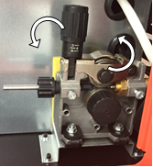

5.1.2.2 check the wire drive roller(16) groove matches the selected MIG wire type and size. The drive roller will have two different sized grooves, the size of the groove in use is stamped on the side of the drive roller. For flux cored ‘soft’ wire ,such as that used in gasless MIG welding, the drive roller groove has a serrated profit. For solid ‘hard’ MIG wire, the roller groove has a ‘v’ shaped profile
5.1.2.3 the drive roller(16) is removed by threading the drive roller retainer(17) off in the anti-clockwise direction. Once the correct drive roller profile is selected, re-fit the drive roller.
5.1.2.4 thread the MIG wire from the spool through the input guide tube(15), through the roller groove and into the outlet guide tube
5.1.2.5 Replace the tension arm (14) and the tension adjustment (13). Double check the wire has located correctly in the drive roller groove.
5.1.2.6 Adjusting wire feed tension: this is accomplished by winding the knob on the wire tension adjustment arm (14). Clockwise will increase tension, anti-clockwise will decrease tension. There is a numbered scale on the tensioner to indicate the position. Ideal tension should be as little as possible, while maintaining a consistent wire feed with no drive roller slippage. Check all other possible causes of slippage, such as; incorrect/ worn drive roller, worn/ damaged torch consumables, blocked/ damaged torch feed liner, before increasing feed tension.

Warning! - Before changing the feed roller or wire spool, ensure that the mains power is switched off

Warning! - The use of excessive feed tension will cause rapid and premature wear of the drive roller, the support bearing and the drive motor.

5.1.3 setup for gasless MIG welding operation

5.1.3.1 Connect the MIG Torch Euro Connector (21) to the torch socket on the front of the welder (5). Secure by firmly hand tightening the threaded collar on the MIG Torch Euro Connector clockwise.
5.1.3.2 Check that the correct flux cored, gasless wire, matching drive roller (16) and welding tip (25) are fitted
5.1.3.3 Connect Torch Connection Power Lead (8) to the negative (-) welding output terminal (7).
5.1.3.4 Connect Earth Lead Quick Connector (24) to the positive (+) output welding terminal (6). See picture below.
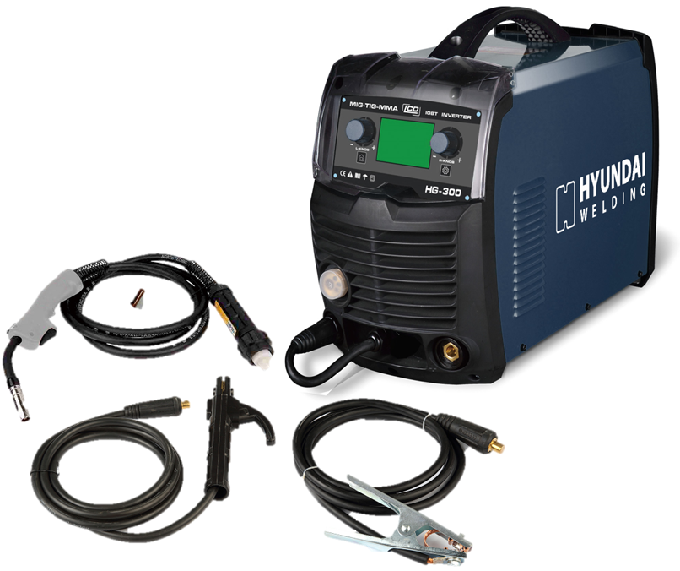

5.1.3.5 Connect Earth Clamp (22) to the work piece. Contact with workpiece must be strong contact with clean, bare metal, with no corrosion, paint or scale at the contact point.

5.1.4 Setup for gas shielded MIG welding operation
Note - Gas shielded MIG welding requires a shielding gas supply, gas regulator and gas shielded MIG wire. These accessories are not supplied standard with the RW1500MP. Please contact your local Repco branch for details
5.1.4.1 Connect the MIG Torch Euro Connector (21) to the torch socket on the front of the welder (5). Secure by firmly hand tightening the threaded collar on the MIG Torch Euro Connector clockwise.
5.1.4.2 Check that the correct gas shielded wire, matching drive roller (16) and welding tip (25) are fitted
5.1.4.3 Connect Torch Connection Power Lead (8) to the positive (+) welding output terminal (6)
5.1.4.4 Connect Earth Lead Quick Connector (22) to the negative (-) output welding terminal (7). See picture below

5.1.4.5 Connect Earth Clamp (22) to the work piece. Contact with workpiece must be strong contact with clean, bare metal, with no corrosion, paint or scale at the contact point.
5.1.4.6 Connect the gas regulator (optional) and gas line to the inlet on the rear panel (11). If the regulator is equipped with a flow gauge, the flow should be set between 8 – 15 L/minute depending on application. If gas regulator is not equipped with a flow gauge, adjust pressure so gas can just be heard coming out of the torch conical nozzle (24). It is recommended that gas flow is checked again, just prior to starting weld This can be done by triggering the MIG torch with the unit powered up.

5.1.5 Setup for MMA/STICK mode operation
Note - MMA/Stick Welding requires an MMA lead set .
5.1.5.1 Connect Electrode holder Quick Connector to the positive (+) welding output terminal (12)
5.1.5.2 Connect Earth Lead Quick Connector (30) to the negative (-) output welding terminal (13) See picture below

5.1.6 Setup for Lift TIG welding operation
Note - TIG operation requires an argon gas supply, TIG torch, consumables and gas regulator. These accessories are not included standard with the MIG-GD; contact your supplier for further details.
5.1.6.1Connect Lift TIG torch Quick Connector to the negative (-) output welding terminal (13)
5.1.6.2 Connect Earth Lead Quick Connector (30) to the positive (+) welding output terminal (12).
5.1.6.3 Connect the air hose of Lift tig torch with the Argon meter connector. See picture below

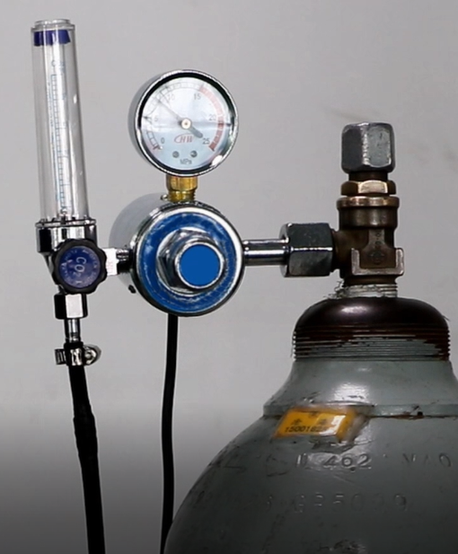

Connection of Shield Gas

Connect the CO₂ hose, which come from the wire feeder to the copper nozzle of gas bottle. The gas supply system includes the gas bottle, the air regulator and the gas hose, the heater cable should be inserted into the socket of machine’s back, and use the hose clamp to tighten it to prevent leaking or air-in, so that the welding spot is protected.
Please note:

- Leakage of shielding gas affects the performance of arc welding.
- Avoid the sun shine on the gas cylinder to eliminate the possible explosion of gas cylinder due to the increasing pressure of gas resulted from the heat.
- It is extremely forbidden to knock at gas cylinder and lay the cylinder horizontally.
- Ensure no person is up against the regulator, before the gas release or shut the gas output.
- For MIG-250GW and MIG-250GF, insert the power supply plug of the heater into the 36 VAC (5A) socket on the back panel of the welding machine.
- The gas output volume meter should be installed vertically to ensure the precisely measuring.
- Before the installation of gas regulator, release and shut the gas for several time in order to remove the possible dust on the sieve to avail the gas output.

Note: Since the arc of MIG welding is much strong than that of MMA welding, please wear welding helmet and protective clothing.

5.1.5 Controls for MIG welding
5.1.5.1 Switch the machine on using the mains power switch (10). Wait 5 seconds for the digital control program to load up. Press the Left button (2) to mode section, and select the mode by Left knob (1), and press the Left knob (1) to confirm the selection.

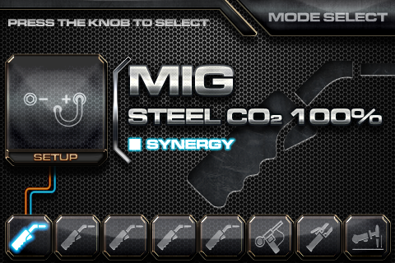

5.1.5.2 The multifunction digital display will show two numbers. On the left is the preset welding voltage, on the right is the preset wire feeding speed. These values are adjusted by rotating the Right knob (3). Because of the synergic digital programming, both the voltage and the wire speed will adjust together.
Preset welding voltage
Wire feed speed

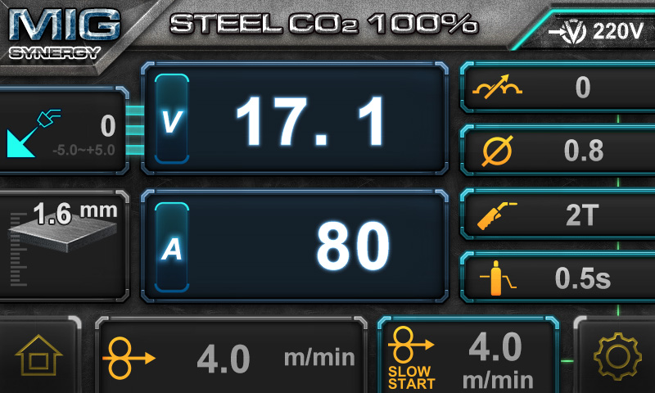

5.1.5.3 To adjust the voltage independently, Rotate Left Knob (1) to adjust the welding voltage. This will change and give the display screen as below.
Then use the Left knob (1) to adjust the welding voltage 0-2V from the standard synergic setting. This will not change the wire speed. It is recommended for ease of use that the wirefeed target speed is adjusted first and then the voltage setting fine- tuned if necessary. Refer to the Welding Settings Quick Reference Chart on page 21 and inside the wirefeed door for recommended common settings.

±5V

5.1.5.4 Press the Right button (4) again to adjust the inductance of the welding arc. Use the Right Knob (3) to adjust the inductance from 0 (less inductance) to +20 (more inductance).
A quick note regarding inductance – this effectively adjusts the intensity of the welding arc.inductance makes the arc ‘softer’, with less weld spatter. Higher inductance gives a stronger driving arc which can increase penetration. Optimum inductance settings are affected by many welding variables such as: material type, shielding gas joint type, welding amperage, wire size.
welding amperage, wire size.

The default value of inductance is 10, it is recommended to keep this value unless the operator is an experienced welder.
5.1.5.5 Press the Right Button (4) again to return to the main wires peed/voltage adjustment screen. If the control panel is not adjusted after 5 seconds it will also return to the primary MIG adjustment mode. Or press the Left/Right (1)/(3) to return to the primary MIG adjustment mode directly.
5.1.5.6 During welding the screen display will change to show the actual welding voltage and welding current as pictured below
Actual welding voltage
Actual welding current

5.1.5.7 2T/4T function: press the Right Button (4) ,2T/4T Selection Switch to move between 2T and 4T modes. 4T operation means the trigger is pulled once to start welding and pulled again to stop. This is useful for long weld joints. 2T mode, the trigger must be depressed and held during welding.

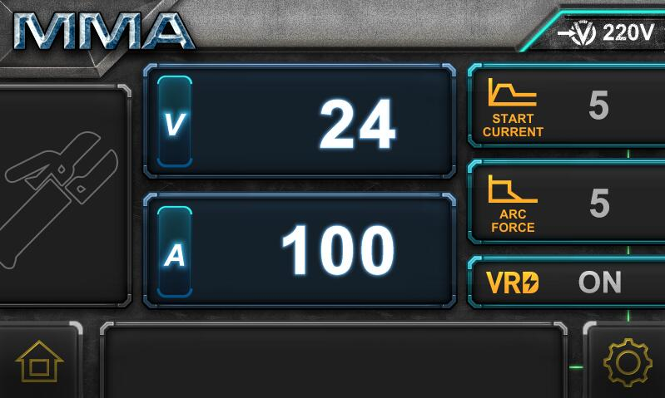

5.1.5.8 Wire check function: press the Right Button (4) again to enter to the wire check mode, rotate Right knob (3) to select ON/OFF

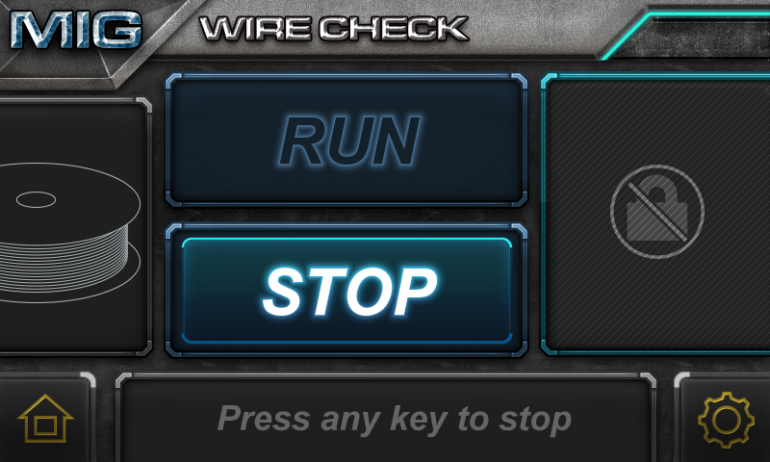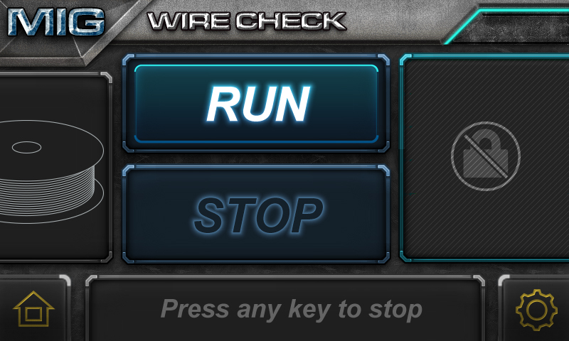
5.1.6 Feeding the wire
1.6.1 Remove the conical nozzle (24) and the welding tip (25) from the torch. The conical nozzle is removed by turning clockwise and pulling off simultaneously. The welding tip threads out of the tip adapter.
5.1.6.2 With the wire feed cover door still open pull the torch trigger (20) and check that the wire is feeding smoothly through the feed roller and into the torch
5.1.6.3 Now stretch the torch lead and handle out as straight as possible from the machine and select the wire check function. This will start the feed motor running at full speed to feed the wire through the torch liner.
5.1.6.4 Once the wire comes out past the end of the torch neck, pull the torch trigger or press any button on the display to stop the automatic wire feed.
5.1.6.5 Close the wire feed cover door
5.1.6.6 Replace the welding tip (25) and conical nozzle (24) back onto the torch neck and trim off any excess wire
You are now ready to weld!

5.1.7 MMA/STICK mode operation
Note - MMA/Stick Welding requires an MMA lead set .
5.1.7.1 Connect Earth Lead Quick Connector (23) to the negative (-) output welding terminal (7).
5.1.7.2 Connect Earth Clamp (22) to the work piece. Contact with workpiece must be strong contact with clean, bare metal, with no corrosion, paint or scale at the contact point

5.1.7.3 Connect the ARC/electrode holder lead (optional) to the positive (+) welding output terminal Note – some welding electrode types utilize different connection polarity. If in doubt, contact the electrode manufacturer
5.1.7.4 Turn the machine on at the Mains Power Switch (10).
5.1.7.5 Press the Left button (2) to mode section, and select the mode by Left knob (1), and press the Left knob (1) to confirm the MMA selection.
The screen will show the preset MMA welding current. This can be adjusted by rotating the Welding Parameter Adjustment
Knob (3).
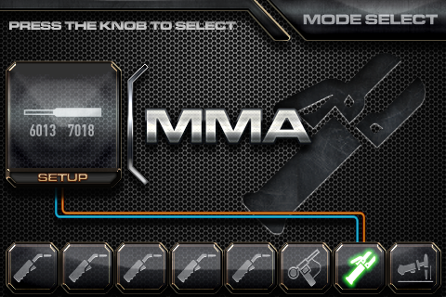

5.1.7.6 When welding the display will change to show actual welding volts and amperage.

5.1.7.7 VRD: VRD stands for Voltage Reduction Device. The open circuit voltage at the output terminals of an MMA welding power source is high enough to potentially cause an electric shock to a person if they come into contact with the live terminals. VRD is a safety system that reduces this open circuit voltage to a level where the risk of electric shock is minimized. It does, however, make striking of the arc more difficult. Press the Right button (4) to switch VRD on/off.

5.1.8 Lift TIG operation
Note - TIG operation requires an argon gas supply, TIG torch, consumables and gas regulator. These accessories are not included standard with the MIG-GS/GD; contact your supplier for further details.
5.1.8.1 Connect Earth Lead Quick Connector (23) to the positive (+) output welding terminal (6).
5.1.8.2 Connect Earth Clamp (22) to the work piece. Contact with workpiece must be strong contact with clean, bare metal, with no corrosion, paint or scale at the contact point.
5.1.8.3 Connect the TIG torch power lead to the negative (-) welding output terminal (7).
1.8.4 Connect the gas supply to the TIG torch.
5.1.8.5 Turn the machine on at the Mains Power Switch (10).
5.1.8.6 Press the Left button (2) to mode section, and select the mode by Left knob (1), and press the Left knob (1) to confirm the LIFT TIG selection.
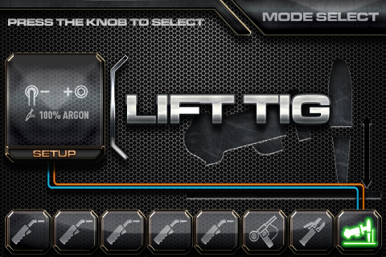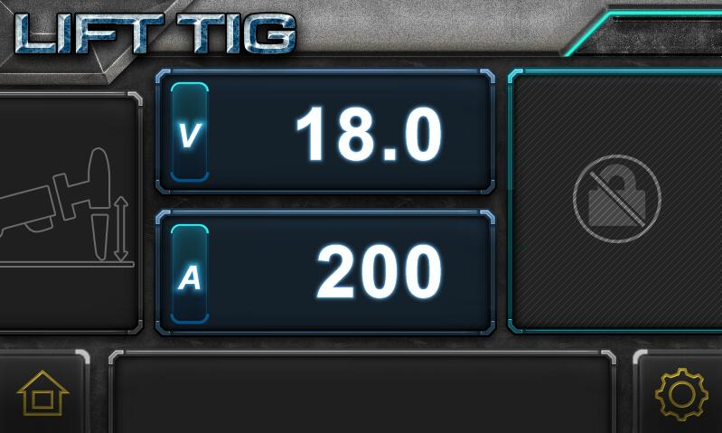

The screen will show the preset LIFT TIG welding current. This can be adjusted by rotating the Right Knob (3)
5.1.8.7 When welding the display will change to show actual welding volts and amperage.

6.Welding settings quick reference chart

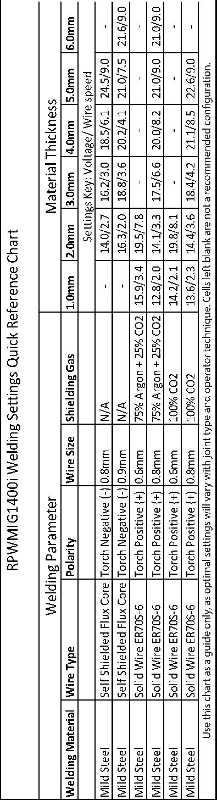

Basic welding guide
MIG (GMAW/FCAW) Basic Welding Technique
Two different welding processes are covered in this section (GMAW and FCAW), with the intention providing the very basic concepts in using the MIG mode of welding, where a welding gun is hand held, and the electrode (welding wire) is fed into a weld puddle, and the arc is shielded by an inert welding grade shielding gas or inert welding grade shielding gas mixture.

GAS METAL ARC WELDING (GMAW): This process, also known as MIG welding, CO2 welding, Micro Wire Welding, short arc welding, dip transfer welding, wire welding etc., is an electric arc welding process which fuses together the parts to be welded by heating them with an arc between a solid continuous, consumable electrode and the work. Shielding is obtained from an externally supplied welding grade shielding gas or welding grade shielding gas mixture. The process is normally applied semi automatically; however the and fairly thick steels, and some non-ferrous metals in all positions.

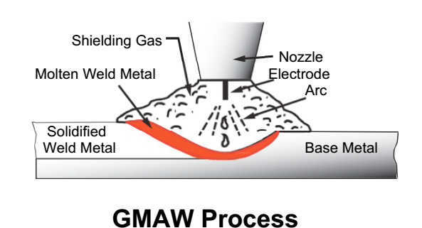

FLUX CORED ARC WELDING (FCAW): This is an electric arc welding process which fuses together the parts to be welded by heating them with wan arc between a continuous flux filled electrode wire and the work. Shielding is obtained through decomposition of the flux within the tubular wire. Additional shielding may or may not be obtained from an externally supplied gas or gas mixture. The process is normally applied semi automatically; however the process may be applied automatically or by machine. It is commonly used to weld large diameter electrodes in the flat and horizontal position and small electrode diameters in all positions. The process is used to a lesser degree for welding stainless steel and for overlay work.

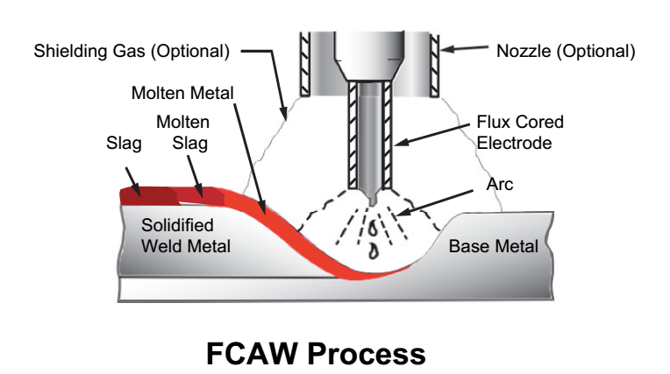

Position of MIG Torch
The angle of MIG torch to the weld has an effect on the width of the weld
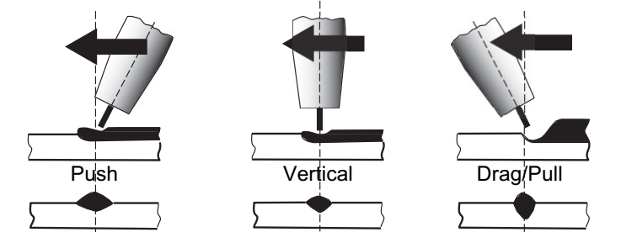

The welding gun should be held at an angle to the weld joint. (See Secondary Adjustment Variables below) Hold the gun so that the welding seam is viewed at all times. Always wear the welding helmet with proper filter lenses and use the proper safety equipment.

CAUTION
Do not pull the welding gun back when the arc is established. This will create excessive wire extension (stick-out) and make a very poor weld.
The electrode wire is not energized until the gun trigger switch is depressed. The wire may therefore be placed on the seam or joint prior to lowering the helmet.
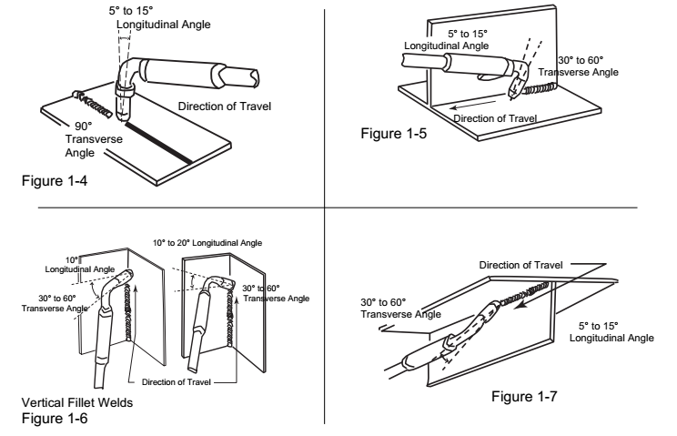

Distance from the MIG Torch Nozzle to the Work Piece
The electrode wire stick out from the MIG Torch nozzle should be between 10mm to 20.0mm. This distance may vary depending on the type of joint that is being welded

Travel Speed
The speed at which the molten pool travels influences the width of the weld and penetration of the welding run

MIG Welding (GMAW) Variables
Most of the welding done by all processes is on carbon steel. The items below describe the welding.
variables in short-arc welding of 24gauge (0.024”, 0.6mm) to ¼” (6.4mm) mild sheet or plate. The applied techniques and end results in the GMAW process are controlled by these variables.

Preselected Variables
Preselected variables depend upon the type of material being welded, the thickness of the material, the welding position, the deposition rate and the mechanical properties. These variables are:
Type of electrode wire
Size of electrode wire
Type of gas (not applicable to self-shielding wires FCAW)
Gas flow rate (not applicable to self-shielding wires FCAW)

Primary Adjustable Variables
These control the process after preselected variables have been found. They control the penetration, bead width, bead height, arc stability, deposition rate and weld soundness. They are:
Arc Voltage
Welding current (wire feed speed)
Travel speed

Secondary Adjustable Variables
These variables cause changes in primary adjustable variables which in turn cause the desired change in the bead formation. They are:
1.Stick-out (distance between the end of the contact tube (tip) and the end of the electrode wire). Maintain at about 10mm stick-out
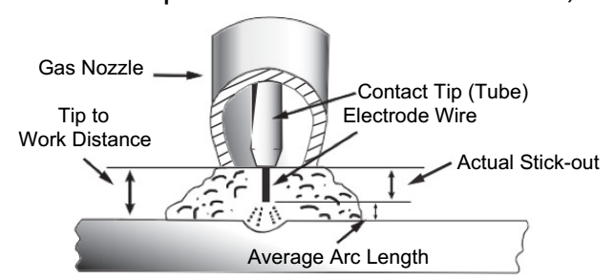
2. Wire Feed Speed. Increase in wire feed speed increases weld current, Decrease in wire feed speed decreases weld current

3. Nozzle Angle. This refers to the position of the welding gun in relation to the joint. The transverse angle is usually one half the included angle between plates forming the joint. The longitudinal angle is the angle between the centre line of the welding gun and a line perpendicular to the axis of the weld. The longitudinal angle is generally called the Nozzle Angle and can be either trailing (pulling) or leading
(pushing). Whether the operator is left handed or right handed has to be considered to realize the effects
of each angle in relation to the direction of travel.

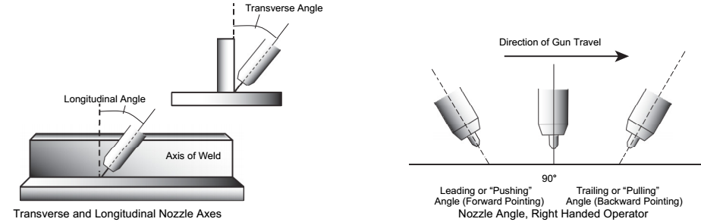

Establishing the Arc and Making Weld Beads
Before attempting to weld on a finished piece of work, it is recommended that practice welds be made on a sample metal of the same material as that of the finished piece

The easiest welding procedure for the beginner to experiment with MIG welding is the flat position. The equipment is capable of flat, vertical and overhead positions.

For practicing MIG welding, secure some pieces of 16 or 18 gauge (0.06” 1.5mm or 0.08” 2.0mm) mild steel plate 6” x 6” (150 x 150mm). Use 0.030” (0.8mm) flux cored gasless wire or a solid wire with shielding gas

Setting of the Power Source
Power source and Wirefeeder setting requires some practice by the operator, as the welding plant has two control settings that have to balance. These are the Wirespeed control and the welding Voltage Control. The welding current is determined by the Wirespeed control, the current will increase with increase Wirespeed, resulting in a shorter arc. Less wire speed will reduce the current and lengthen the Increasing the welding voltage hardly alters the current level, but lengthens the arc. By decreasing voltage, a shorter arc is obtained with a little change in current level.

When changing to a different electrode wire diameter, different control settings are required. A thinner electrode wire needs more Wirespeed to achieve the same current level

A satisfactory weld cannot be obtained if the Wirespeed and Voltage settings are not adjusted to suit the electrode wire diameter and the dimensions of the work piece.

If the Wirespeed is too high for the welding voltage, “stubbing” will occur as the wire dips into the molten pool and does not melt. Welding in these conditions normally produces a poor weld due to lack of fusion. If, however, the welding voltage is too high, large drops will form on the end of the wire, causing spatter. The correct setting of voltage and Wirespeed can be seen in the shape of the weld deposit and heard by a smooth regular arc sound. Refer to the Weld Guide located on the inside of the wirefeed compartment door for setup information.

Electrode Wire Size Selection
The choice of Electrode wire size and shielding gas used depends on the following
Thickness of the metal to be welded
Capacity of the wire feed unit and Power Source
The amount of penetration required
The deposition rate required
The bead profile desired
The position of welding
Cost of the wire

7.Range of welding current and voltage in CO₂ welding
Wireφ(mm) | Short circuit transition |  | Granular transition
Wireφ(mm) | Current（A） | Voltage (V) | Current（A） | Voltage (V)
0.6 | 40~70 | 17~19 | 160~400 | 25~38
0.8 | 60~100 | 18~19 | 200~500 | 26~40
1.0 | 80~120 | 18~21 | 200~600 | 27~40
-The option of the welding speed
The welding quality and productivity should be taken into consideration for the option of welding speed. In case that the welding speed increases, it weakens the protection efficiency and speeds up the cooling process. As a consequence, it is not optimal for the seaming. In the event that the speed is too slow, the work piece will be easily damaged, and the seaming is not ideal. In practical operation, the welding speed should not exceed 1m/min.

-The length of wire stretching out
The length of wire stretching out the nozzle should be appropriate. The increase of the length of wire stretching out of the nozzle can improve the productivity, but if it is too long, excessive spatter will occur in the welding process. Generally, the length of wire stretching out the nozzle should be 10 times as the welding wire diameter.

-The setting of the C0₂ flow volume
The protection efficiency is the primary consideration. Besides, inner-angle welding has better protection efficiency than external-angel welding. For the main parameter, refer to the following figure.

Option of C0₂ flow volume
Welding mode | Thin wire C0₂ welding | Thick wire C0₂ welding | Thick wire, big current C0₂ welding
C0₂（L/min） | 5～15 | 15～25 | 25～50

8.WELDING PARAMETERS TABLE
The option of the welding current and welding voltage directly influences the welding stability, welding quality and productivity. In order to obtain the good welding quality, the welding current and welding voltage should be set optimally. Generally, the setting of weld condition should be according to the welding diameter and the melting form as well as the production requirement.
The following parameter is available for reference.

Parameter for butt-welding (Please refer to the following figure.)

Plate thickness  t（mm） | Gap  g(mm) | Wire  φ(mm) | Welding current  （A） | Welding voltage  （V） | Welding speed  （cm/min） | Gas volume  （L/min）
0.8 | 0 | 0.8~0.9 | 60~70 | 16~16.5 | 50~60 | 10
1.0 | 0 | 0.8~0.9 | 75~85 | 17~17.5 | 50~60 | 10~15
1.2 | 0 | 1.0 | 70~80 | 17~18 | 45~55 | 10
1.6 | 0 | 1.0 | 80~100 | 18~19 | 45~55 | 10~15
2.0 | 0~0.5 | 1.0 | 100~110 | 19~20 | 40~55 | 10~15
2.3 | 0.5~1.0 | 1.0 or 1.2 | 110~130 | 19~20 | 50~55 | 10~15
3.2 | 1.0~1.2 | 1.0 or 1.2 | 130~150 | 19~21 | 40~50 | 10~15
4.5 | 1.2~1.5 | 1.2 | 150~170 | 21~23 | 40~50 | 10~15

Parameter for flat fillet welding (Please refer to the following figure.)

Plate thickness  t（mm） | Corn size  I (mm) | Wire  φ(mm) | Welding current  （A） | Welding voltage  （V） | Welding speed  （cm/min） | Gas volume  （L/min）
1.0 | 2.5~3.0 | 0.8~0.9 | 70~80 | 17~18 | 50~60 | 10~15
1.2 | 2.5~3.0 | 1.0 | 70~100 | 18~19 | 50~60 | 10~15
1.6 | 2.5~3.0 | 1.0 ~ 1.2 | 90~120 | 18~20 | 50~60 | 10~15
2.0 | 3.0~3.5 | 1.0 ~ 1.2 | 100~130 | 19~20 | 50~60 | 10~20
2.3 | 2.5~3.0 | 1.0 ~ 1.2 | 120~140 | 19~21 | 50~60 | 10~20
3.2 | 3.0~4.0 | 1.0 ~ 1.2 | 130~170 | 19~21 | 45~55 | 10~20
4.5 | 4.0~4.5 | 1.2 | 190~230 | 22~24 | 45~55 | 10~20

Parameter for fillet welding in the vertical position (Please refer to the following figure.)

Plate thickness  t（mm） | Corn size  I (mm) | Wire  φ(mm) | Welding current  （A） | Welding voltage  （V） | Welding speed  （cm/min） | Gas volume  （L/min）
1.2 | 2.5~3.0 | 1.0 | 70~100 | 18~19 | 50~60 | 10~15
1.6 | 2.5~3.0 | 1.0 ~ 1.2 | 90~120 | 18~20 | 50~60 | 10~15
2.0 | 3.0~3.5 | 1.0 ~ 1.2 | 100~130 | 19~20 | 50~60 | 10~20
2.3 | 3.0~3.5 | 1.0 ~ 1.2 | 120~140 | 19~21 | 50~60 | 10~20
3.2 | 3.0~4.0 | 1.0 ~ 1.2 | 130~170 | 22~22 | 45~55 | 10~20
4.5 | 4.0~4.5 | 1.2 | 200~250 | 23~26 | 45~55 | 10~20

Parameter for Lap Welding (Please refer to the following figure.)

Plate thickness  t（mm） | Welding position | Wire  φ(mm) | Welding current  （A） | Welding voltage  （V） | Welding speed  （cm/min） | Gas volume  （L/min）
0.8 | A | 0.8~0.9 | 60~70 | 16~17 | 40~45 | 10~15
1.2 | A | 1.0 | 80~100 | 18~19 | 45~55 | 10~15
1.6 | A | 1.0 ~ 1.2 | 100~120 | 18~20 | 45~55 | 10~15
2.0 | A or B | 1.0 ~ 1.2 | 100~130 | 18~20 | 45~55 | 15~20
2.3 | B | 1.0 ~ 1.2 | 120~140 | 19~21 | 45~50 | 15~20
3.2 | B | 1.0 ~ 1.2 | 130~160 | 19~22 | 45~50 | 15~20
4.5 | B | 1.2 | 150~200 | 21~24 | 40~45 | 15~20

9.CAUTION
1. Working environment
⑴ Welding should be carried out in a relatively dry environment with its humidity of 90% or less.
⑵ The temperature of the working environment should be within -10°C to 40°C.
⑶ Avoid welding in the open air unless sheltered from sunlight and rain, and never let rain or water infiltrate the machine.
⑷ Avoid welding in dusty area or environment with corrosive chemical gas.
⑸ Avoid gas shielded arc welding in environment with strong airflow.

2. Safety tips
Over-current/overheating protection circuit is installed in this welding machine. If the output current is too high or overheating generated inside this welding machine, this welding machine will stop automatically. However, inappropriate use will still lead to machine damage, so please note:
1. Ventilation
High current passes when welding is carried out, thus natural ventilation cannot satisfy the welding machine’s cooling requirement. Maintain good ventilation of the louvers of this welding machine. The minimum distance between this welding machine and any other objects in or near the working area should be 30cm. Good ventilation is of critical importance for the normal performance and service life of this welding machine.
2. No over-current.
Remember to observe the max load current at any moment (refer to the optioned duty cycle). Make sure that the welding current should not exceed the max load current.
If welding is carried out under a current which is higher than the max current, over-current protection will occur; the output voltage of the welding machine will be not stable; arc interruption will occur. In this case, please lower the current.
3. No over-load.
Over-load current could obviously shorten the welding equipment’s life, or even damage the machine.
A sudden halt may occur while the welding operation is carried out while this welding machine is of over-load status. Under this circumstance, it is unnecessary to restart this welding machine. Keep the built-in fan working to bring down the temperature inside the welding machine.
4. Avoid electric shock.
An earth terminal is available for this welding equipment. Connect it with the earth cable to avoid the static and electric shock.

10.MAINTENANCE
- Disconnect input plug or power before maintenance or repair on machine.
- Be sure input ground wire is properly connect to a ground terminal.
- Check whether the inner gas-electricity connection is well (esp. the plugs), and tighten the loose connection; if there is oxidization, remove it with sand paper and then re-connect.

- Keep hands, hair, loose clothing, and tools away from electrical parts such as fans, wires when the machine is switched on.

- Clear the dust at regular intervals with clean and dry compressed air; if the working condition is with heavy smoke and air pollution, the welding machine should be cleaned daily.
- The compressed air should be reduced to the required pressure lest the little parts in the welding machine be damaged.

- To avoid water and rain, if there is, dry it in time, and check the insulation with mega-meter (including that between the connection and that between the case and the connection). Only when there is no abnormal phenomenon should the welding continue.
- If the machine is not used for a long time, put it into the original packing in dry condition.

11.DAILY CHECKING
To make best use of the machine, daily checking is very important. During the daily checking, please check in the order of torch, wire-feeding vehicle, all kinds of PCB, the gas hole, and so on. Remove the dust or replace some parts if necessary. To maintain the purity of the machine, please use original welding parts.
Cautions：Only the qualified technicians are authorized to undertake the repair and check task of this welding equipment in case of machine fault.
11.1. Power supply
Part | Check | Remarks
Control panel | - Operation, replacement and installation of Switch.
Control panel | - Switch on the power, and check if the power indicator is on.
Fan | - Check if the fan is functioning and the sound generated is normal. | If the fan doesn’t work or the sound is abnormal, do inner check.
Power supply | - Switch on the power supply, and check if abnormal vibration, heating of the case of this equipment, variation of colors of case or buzz presents.
Other parts | - Check if gas connection is available, case and other joints are in good connection.

11.2. Welding torch
Part | Check | Remarks
Nozzle | - Check if the nozzle is fixed firmly and distortion of the tip exists. | Possible gas leakage occurs due to the unfixed nozzle.
Nozzle | - Check if there is spatter sticking on the nozzle. | Spatter possibly leads to the damage of torch. Use anti-spatter to eliminate the spatter.
Contact tip | - Check if the contact tip is fixed firmly. | Unfixed contract tip possibly leads to unstable arc.
Contact tip | - Check if the contact tip is physically complete. | The physically incomplete contact tip possibly leads to unstable arc and arc automatically terminating.
Wire feeding hose | - Make sure that there is the agreement of wire and wire feed tube. | Disagreement of the diameters of wire and wire feed tube possibly leads to the unstable arc. Replace it/them if necessary.
Wire feeding hose | - Make sure that there is no bending or elongation of wire feed tube. | Bending and elongation of wire feed tube possibly leads to the unstable wire feed and arc. Replace it if necessary.
Wire feeding hose | - Make sure that there is no dust or spatter accumulated inside the wire feed tube, which makes the wire feed tub blocked. | If there is dust or spatter, remove it.
Wire feeding hose | - Check if the wire feed tube and O-shaped seal ring are physically complete. | The Physically incomplete wire feed tube or O-shaped seal ring possibly leads to the excessive spatter. Replace the wire feed tube or O-shaped seal ring if necessary.

Part | Check | Remarks
Diffuser | - Make sure that the diffuser of required specification is installed and is unblocked. | Defection weld or even the damage of torch occurs due to the non-installation of diffuser or the unqualified diffuser.

11.3. Wire feeder
Part | Check | Remarks
Pressure adjusting handle | - Check if the pressure-adjusting handle is fixed and adjusted to the desired position. | The unfixed pressure-adjusting handle leads to the unstable welding output.
Wire-feeding hose | - Check if there is dust or spatter inside the hose or beside wire-feeding wheel. | Remove the dust.
Wire-feeding hose | - Check if there is a diameter agreement of wire and wire-feeding hose. | Non-agreement of the diameter of wire and wire-feeding hose possibly leads to the excessive spatter and unstable arc.
Wire-feeding hose | - Check if rod and wire feeding groove are concentric. | Unstable arc possibly occurs.
Wire-feeding wheel | - Check if there is an agreement of wire diameter and wire-feeding wheel. | Non-agreement of wire diameter and wire-feeding wheel possibly leads to the excessive spatter and unstable arc.
Wire-feeding wheel | - Check if the wire groove is blocked. | Replace it if necessary.
Pressure adjusting wheel | - Check if the pressure adjusting wheel can rotate smoothly, and it’s physically complete. | Unstable rotation or physically incompleteness of the wheel possibly leads to unstable wire feeding and arc.

11.4. Cables
Part | Check | Remarks
Torch cable | - Check if the cable of torch is twisted. | The twisted torch cable leads to unstable wire feeding and arc.
Torch cable | - Check if the coupling plug is in loose connection.
Output cable | - Check if the cable is physically complete. | Relevant measures should be taken to obtain stable weld and prevent the possible electric shock.
Output cable | - Check if insulation damage or loose connection exists.
Input cable | - Check if the cable is physically complete.
Input cable | - Check if insulation damage or loose connection exists.
Earth cable | - Check if the earth cables are well fixed and not short-circuited. | Relevant measures should be taken to prevent the possible electric shock.
Earth cable | - Check if this welding equipment is well grounded.

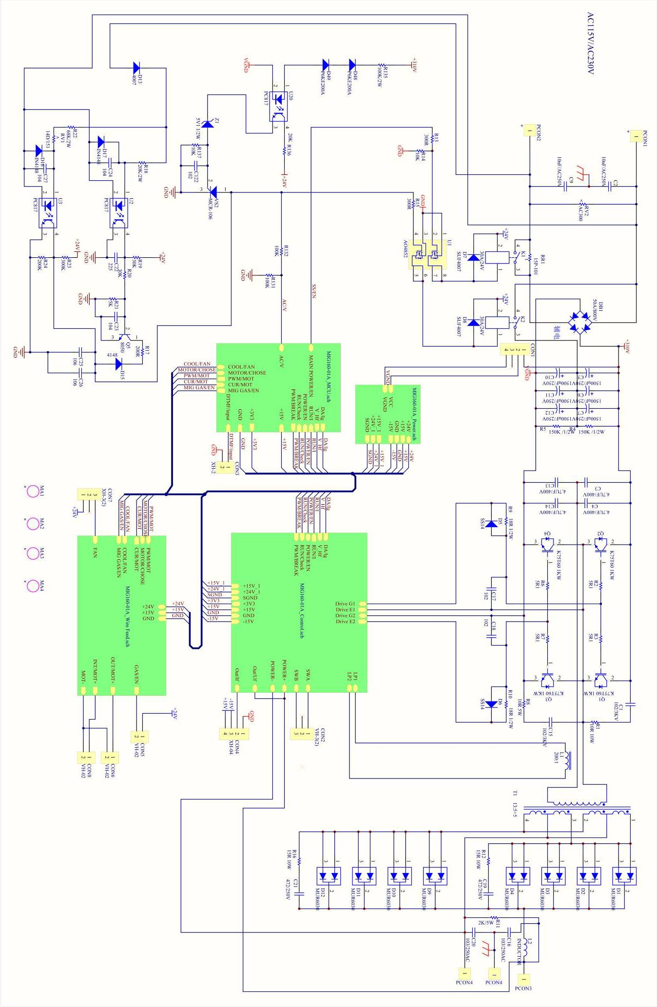
12.CONNECTION DIAGRAM OF THE MACHINE

13.3 HG250/300S

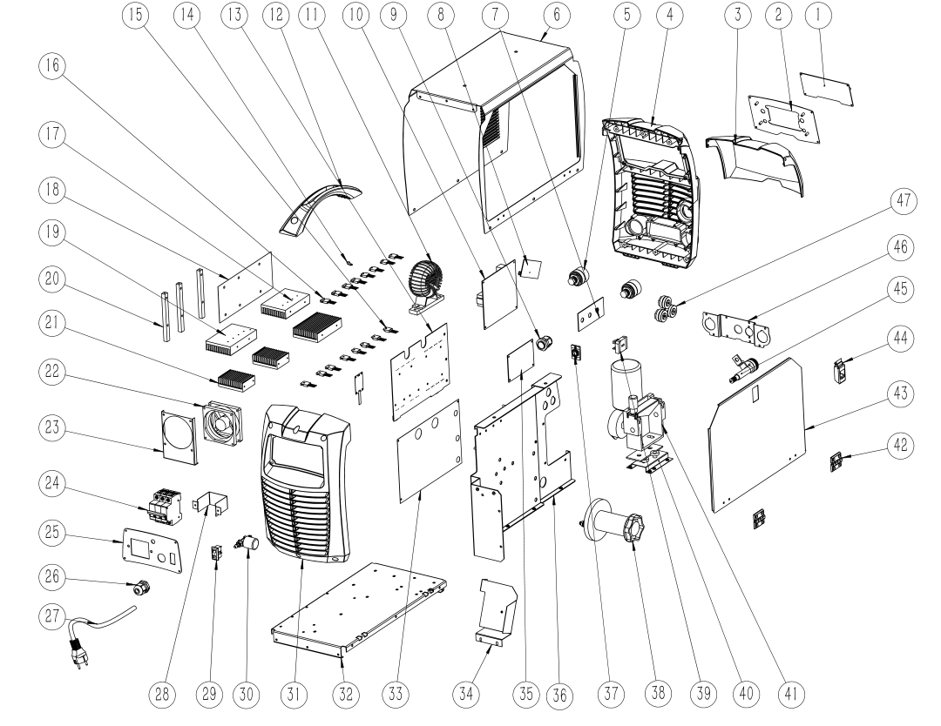

1 | Control PCB board | 17 | Radiator 2 | 33 | Insulation panel
2 | PVB front panel | 18 | Dust shield | 34 | Power shield
3 | Clear front plastic cover | 19 | Radiator 1 | 35 | Filter power board
4 | Black front plastic cover | 20 | Stand 1 | 36 | Clapboard
5 | 35-50 fast connector socket | 21 | Radiator 3 | 37 | Aviation socket
6 | Machine cover | 22 | Fan | 38 | Wire spool holder
7 | Aluminum plate reinforcement | 23 | Fan stand | 39 | Rectifer bridge
8 | Heating power PCB board | 24 | Circuit breaker switch | 40 | Fan stand
9 | Wire buckle | 25 | Rear panel | 41 | Wire feed motor
10 | Contorl PCB board | 26 | Wire buckle | 42 | Hunge
11 | Transformer | 27 | Power cable | 43 | Side door
12 | Handel | 28 | Switch bending piece | 44 | Lock
13 | Main PCB board | 29 | Gas regulator power source | 45 | Euro type connector
14 | Temperature sensor | 30 | Solenoid valve | 46 | Fast connecntor panel
15 | Diod | 31 | Black rear plastic cover
16 | IGBT | 32 | Bottom panel

